CONTROL SIGNALS

**What is control signal?**

Control signals are vital in guiding the internal functions of a computer's central processing unit (CPU). These signals, which are binary codes made up of ones and zeros, dictate the actions of the computer's hardware components.

**Origin and Function**

Produced by the control unit—a critical component of the CPU—control signals come into play by decoding the instructions that are loaded into the CPU. Every instruction triggers a specific series of actions across various parts of the computer such as the arithmetic logic unit (ALU), the memory, and input/output devices. The control unit converts these instructions into a series of control signals that manage and synchronize these activities.

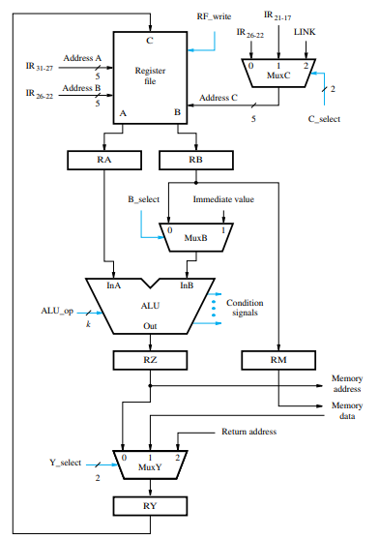**Need of Control Signals**

**Coordination of Components**

Control signals are crucial for coordinating the actions of various components within the computer system. They ensure that different parts, such as the memory, ALU, and input/output devices, operate in sync and perform their tasks at the correct times in the processing cycle.

**Execution of Instructions**

Every instruction that a computer executes requires a specific sequence of operations. Control signals direct these operations, guiding components through the stages of fetching, decoding, executing, and storing results. This orderly process is vital for the CPU to function correctly and efficiently.

**Managing Data Flow**

Control signals regulate the flow of data between the CPU and memory, as well as between registers within the CPU. They control when data is loaded, stored, or transferred, thereby preventing data corruption and ensuring data integrity throughout computational processes.

**Optimization of Performance**

Through precise control and timing of operations, control signals help optimize the performance of a computer system. They allow for the smooth execution of multiple instructions and operations by managing the interactions between hardware components efficiently.

**Enabling Conditional Operations**

Control signals also enable the CPU to perform conditional operations based on the outcomes of previous tasks. For example, they can signal whether a branch in the instruction flow should be taken depending on the results of a logical operation in the ALU.

**Types of Control Signals**

There are several key types of control signals, each associated with different functions within the CPU:

**Memory Control Signals**: These signals oversee the processes of reading from and writing to the computer's memory. For instance, a signal for memory read allows data to be retrieved from a particular memory location and loaded into the CPU for processing.

**ALU Control Signals:** These signals govern the operations within the ALU, the CPU's hub for arithmetic and logical operations, by specifying whether to perform actions such as addition, subtraction, or comparison.

**I/O Control Signals:** These control the exchange of data between the CPU and external devices like keyboards, mice, and printers.

**Register Control Signals:** These manage the movement of data among the CPU's registers—fast, small storage locations essential for the rapid retrieval of data and instructions.

**Importance of Timing**

The success of control signals hinges on precise timing. Each signal must be precisely timed to switch on and off at the right moments to maintain the correct order of operations across the system. This critical timing is regulated by the system's clock, which ensures all components of the computer work in sync.

**How Control Signals are created?**

The Control signals are generated in two ways by,

1. Hardwired control,

2 .Microprogrammed control

**1. Hardwired control:**

Hardwired control is a method used in computer architecture to manage the control unit operations within a CPU using a fixed set of hardware circuits. Unlike microprogrammed control, which uses software to implement the control unit, hardwired control relies on a specific arrangement of logic gates, flip-flops, and other electronic components to directly execute control signals.

The operational flow in hardwired control can be described as follows:

1. Instruction Fetch: The system fetches instructions from memory.

2. Instruction Decode: The instruction is decoded to understand what actions are necessary.

3.Signal Generation: Based on the decoded information, the hardwired logic circuits produce specific control signals that instruct other components of the CPU to perform operations such as data fetching, computation, data storage, or data output.

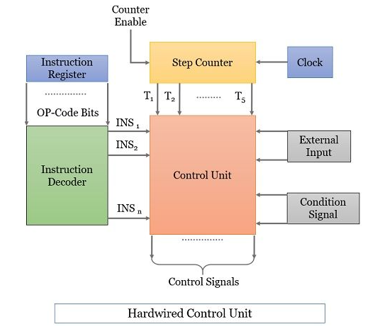

**2. Microprogrammed control**

Microprogrammed control is a technique used to manage the operations of a computer's control unit via a set of small instructions known as microinstructions. These microinstructions direct the execution of machine instructions at the hardware level. This method contrasts with hardwired control, which uses fixed hardware circuits to dictate CPU operations.

The process typically involves the following steps:

1. Instruction Decode: When a machine instruction is fetched from main memory, it is decoded to determine the required operations.

2. Fetch Microinstructions: Based on the decoded instruction, a starting address in the control store is accessed to fetch the corresponding microinstructions.

3. Execute Microinstructions: These microinstructions are then sequentially executed to generate the appropriate control signals for the CPU components, guiding them through the steps necessary to complete the machine instruction.

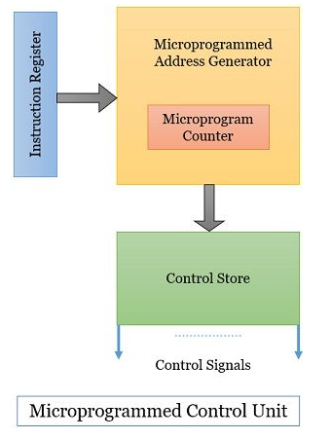

**Conclusion:**

Control signals are fundamental to the operation of a computer, coordinating the myriad of tasks that occur within the CPU. Without these signals, the organized, sequential processing required to execute complex instructions and tasks would not be possible. The proper generation and management of control signals enable efficient processing and are a key aspect of computer architecture design.

Prepared by:

Varshan.A.V.K

660471